Lithium Iron Phosphate Battery Specification

# Customer

**Part name** Stacked Energy Storage Power Supply

**Model No** PKG-SP512100-S-ACB

# Serial No

**Produce No**

|  |  |  |  |
| --- | --- | --- | --- |
| **Approved by** |  | **Drafted by** | Xiaojun Nie |
| **Checked by** |  | **Signed by** | Wenfei Liang |
| **Prepared by** |  | **Date** | 2023-03-10 |

## Company address: 7th Floor, block B, Yicheng Huanzhi center, Renmin Road, Longhua District, Shenzhen, China.

（Tel）： +86-755-86670672

（Fax）：+86-755-86670609

E-mail： [sales@pknergy.com](mailto:sales@pknergy.com) Website： [http://www.pknergy.com](http://www.pknergy.com/)

Product Modified Record List

|  |  |  |  |
| --- | --- | --- | --- |
| Revision | Date | Modified Content | Corrected person |
| A1 | 2023-03-10 |  |  |
| A2 | 2023-03-30 | Version Fixes | Xiaojun Nie |
|  |  |  |  |
|  |  |  |  |
|  |  |  |  |
|  |  |  |  |
|  |  |  |  |
|  |  |  |  |
|  |  |  |  |
|  |  |  |  |
|  |  |  |  |
|  |  |  |  |
|  |  |  |  |
|  |  |  |  |
|  |  |  |  |
|  |  |  |  |
|  |  |  |  |

## Scope

The specification shall be applied to LiFePO4 rechargeable battery pack Of PKG-SP512100-S-ACB which is manufactured by SHENZHEN PKNERGY ENERGY CO.,LTD

## Battery Pack specifications

|  |  |  |  |  |  |
| --- | --- | --- | --- | --- | --- |
| Package | No. | Item | General Parameter | | Remark |
| 1 | Combination method | 16S1P | | 51.2V 100Ah |
| 2 | Rated Capacity | Typical | 100Ah | Standard discharge after Standard charge (package) |
| Minimum | 98Ah |
| 3 | Factory Voltage | 51V-54V | | Mean Operation Voltage |
| 4 | Voltage at end of Discharge | 46V | | Discharge Cut- off Voltage |
| 5 | Charging Voltage | 58.4V | |  |
| 6 | Internal Impedance | ≤100m Ω | | Internal resistance measured at AC 1 KHZ after 50% charge  The measure must uses the new batteries that within one week after  shipment and cycles less than 5 times |
| 7 | Standard charge | Constant Current 20 A Constant Voltage see No. 5  0.02CA cut-off | | Charge time : Approx 6 h |
| Limiting current | 20A | |  |
| 8 | Standard discharge | Constant current：20 A end voltage see NO.4 | |  |
| 9 | Maximum Continuous  Charge Current | 100A | | T≥ 10ºC |

|  |  |  |  |  |
| --- | --- | --- | --- | --- |
|  | 10 | Maximum Continuous Discharge Current | 100A | T≥ 10ºC |
| 11 | Operation Temperature Range | Charge: 0~45℃ | 60± 25%R .H.  Bare Cell |
| Discharge: -20~55℃ |
| 12 | Storage Temperature Range | Less than 12 months :  -10~35℃ | 60± 25%R .H.  at the shipment state |
| less than 3 months: -10~45℃ |
| Less than 7 day : -20~65℃ |
| 13 | Dimensions | 720*460*190mm | Include Bracket |
| 14 | Weight | Approx： ≈ 50kg |  |

1. BMS function introduction BMS

The BMS is designed for 15/ 16 series lithium battery.

The BMS have all functions which are :

overcharge detection function

over discharge detection function

over current detection function

short detection function

Temperature detection function

balance function

communicate function

Alarm function

Total capacity function

Storage history function

## BMS Protect parameter

|  |  |  |
| --- | --- | --- |
| **Items** | **Details** | Standard |
| Cell overcharge protection | Overcharge detection voltage | 3.65±0.025V |
| Overcharge detection delay time | Typical:1.0s |
| Overcharge release voltage | 3.38±0.02V |
| Cell over-discharge protection | Over-discharge detection voltage | 2.5±0.02V |
| Over-discharge detection delay time | Typical:1.0s |
| Over-discharge release voltage | 2.9±0.02V  or charge release |
| Over-current protection | discharge Over-current protection current1 | 130±10A |
| discharge Over-current detection delay time 1 | 1S |
| discharge Over-current protection current 2 | 150±10A |
| discharge Over-current detection delay time 2 | ≤100m±50ms |
| Charge OC protection current | 130±10A |
| Short protection | Short protection current | 350±100A |
| Protection condition | Load short |
| Detection delay time | ≤300us |
| Protection release condition | Charging release |
| Temperature(T) protection | Charge high T protection | 55±3℃ |
| Charge high T recover | 47±4℃ |
| Discharge high T protection | 60±3℃ |
| Discharge high T recover | 50±4℃ |
| Charge low T protection | 0±3℃ |
| Charge low T recover | 5±4℃ |
| Discharge low T protection | -20±3℃ |
| Discharge low T recover | -10±4℃ |
| Balance | Balance threshold voltage | 3.45V |
| Communication | It has RS232 /RS485 and canbus standard communication interface, it can real-time  monitoring the capacity of battery bank, the voltage, current, environment temperature, and charging/discharging current. | |
| Alarm | It has over-temperature, over charge, under-voltage, over-current, short circuit alarm  Function. | |

1. Appearance and structural dimensions

There shall be no such defect as scratch, bur and other mechanical scratch, and the connector should be no rust dirt. The structure and dimensions see attached drawing of the battery.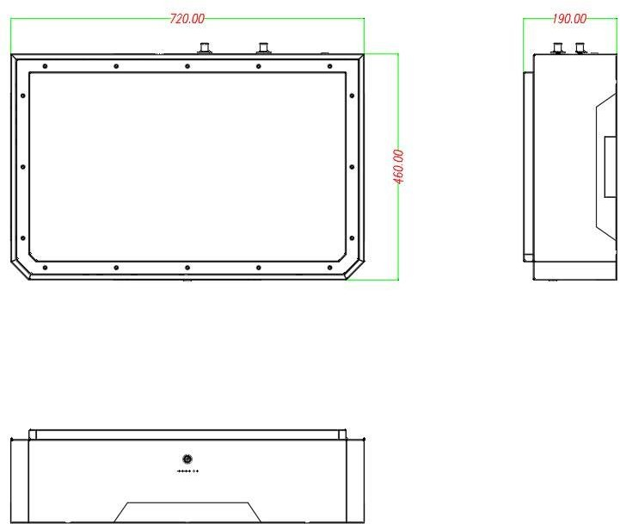

## Parallel machine connection

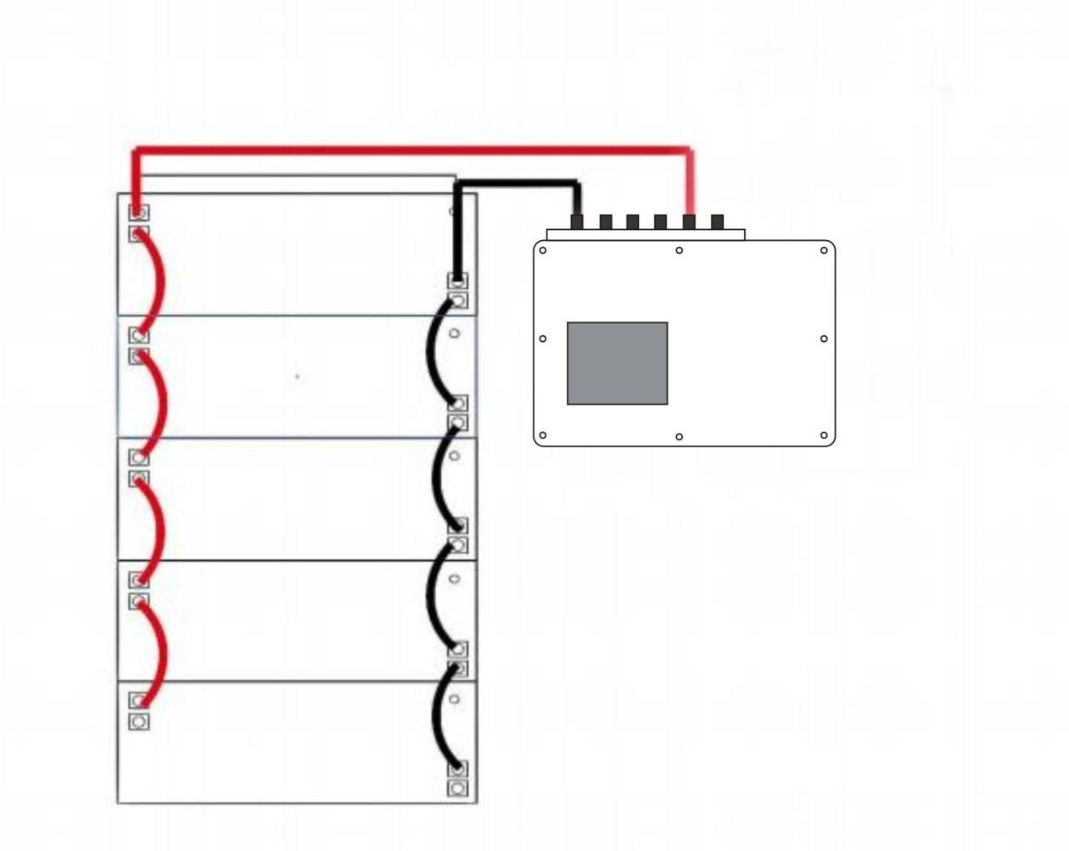

1. Communication interface

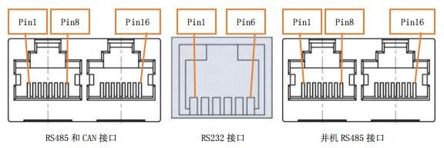

* 1. RS485 and CAN

|  |  |  |  |
| --- | --- | --- | --- |
| RS485（Adopt 8P8C vertical RJ45 socket) | | CAN（Adopt 8P8C vertical RJ45 socket) | |
| RJ45 Pin | Definition Description | RJ45 Pin | Definition Description |
| 1、8 | RS485-B1 | 9、10、11、14、16 | NC |
| 2、7 | RS485-A1 | 12 | CANL |
| 3、6 | GND | 13 | CANH |
| 4、5 | NC | 15 | GND |

6.2 RS232

|  |  |
| --- | --- |
| RS232（Adopt 6P6 vertical RJ11 socket) | |
| RJ11 Pin | Definition Description |
| 1、5、6 | NC |
| 2 | GND |
| 3 | RX( veneer) |
| 4 | TX( veneer) |

6.3 RS485 并机

|  |  |  |  |
| --- | --- | --- | --- |
| RS485（Adopt 8P8C vertical RJ45 socket) | | RS485（Adopt 8P8C vertical RJ45 socket) | |
| RJ45 Pin | Definition Description | RJ45 Pin | Definition Description |
| 1、8 | RS485-B | 9、16 | RS485-B |
| 2、7 | RS485-A | 10、15 | RS485-A |
| 3、6 | GND | 11、14 | GND |
| 4、5 | NC | 12、13 | NC |

## Battery test equipment

* 1. Dimension Measuring Instrument

The dimension measurement shall be implemented by instruments with equal or more precision scale of 0. 1mm.

* 1. Voltmeter

Standard class specified in the national standard or more sensitive class having inner impedance not less than 10 KΩ/V.

* 1. Ammeter

Standard class specified in the national standard or more sensitive class. Total external resistance including ammeter and wire is less than 0.01Ω .

* 1. Impedance Meter

Impedance shall be measured by a sinusoidal alternating current method( AC 1 kHz LCR meter) .

* 1. Standard Test Condition

Test should be conducted with new batteries within one month after shipment from our factory and the cells shall not be cycled more than five times before the test. Unless otherwise defined, test and measurement shall be done under temperature of 23 ±2℃ and relative humidity of less 75%.,air 86Kpa~ 106Kpa.

Unless otherwise defined, 30 min, rest period after charge, 30 min, rest period after discharge.

## Storage and Others

* 1. Long Time Storage

If stored for a long time( don’ t used, exceed three months) , the cell should be stored in drying and cooling place. The cell’ s storage voltage should be 48 . 0 V- 5 1 . 0 V and the cell is to be stored in a condition that the temperature of 23 ±2℃ and the humidity 0f 45%- 75%. Long-term use of unused batteries to recharge every 3 months 。 Ensure that the battery voltage is within the above range 。

* 1. Others

Any matters that this specification does not cover should be conferred between the customer and SHENZHEN PKNERGY ENERGY CO.,LTD

## Amendment of this Specification

This specification is subject to change with prior notice.

## Appendix

### Preface

**Handling Precautions and Guideline For Li- ion Rechargeable Batteries**

This document of ' Handling Precautions and Guideline Li- ion Rechargeable Batteries' shall be applied to the battery cells manufactured by SHENZHEN PKNERGY ENERGY CO.,LTD

**Note (1)** ：

The customer is requested to contact SHENZHEN PKNERGY ENERGY CO.,LTD. in advance, if and when the customer needs other applications or operating conditions than those described in this document. Additional experimentation may be required to verify performance and safety under such conditions.

**Note (2)** ：

SHENZHEN PKNERGY ENERGY CO.,LTD will take no responsibility for any accident when the cell is used under other conditions than those described in this Document.

**Note (3)** ：

SHENZHEN PKNERGY ENERGY CO.,LTD will inform, in a written form, the customer of improvement( s) regarding proper use and handling of the cell, if it is deemed necessary.

### Danger!

— Do not immerse the battery in water or allow it to get wet.

— Do not use or store the battery near sources of heat such as a fire or heater.

— Do not use any chargers other than those recommended by SHENZHEN PKNERGY ENERGY CO.,LTD .

— Do not reverse the positive(+) and negative(-) terminals.

— Do not connect the battery directly to wall outlets or car cigarette- lighter sockets.

— Do not put the battery into a fire or apply direct heat to it.

* Do not short- circuit the battery by connecting wires or other metal objects to the positive( + ) and negative(-) terminals.
* Do not pierce the battery casing with a nail or other sharp object, break it open with a hammer,

or step on it.

* Do not strike, throw or subject the battery to sever physical shock.
* Do not directly solder the battery terminals.
* Do not attempt to disassemble or modify the battery in any way.
* Do not place the battery in a microwave oven or pressurized container.
* Do not use the battery in combination with primary batteries( such as dry- cell batteries) or batteries of different capacity, type or brand.
* Do not use the battery if it gives off an odor, generates heat, becomes discolored or deformed, or appears abnormal in any way. If the battery is in use or being recharged, remove it from the device or charger immediately and discontinue use.

### Caution!

注 意！

Do not use or store the battery where is exposed to extremely hot, such as under window of a car in direct sunlight in a hot day. Otherwise, the battery may be overheated. This can also reduce battery performance and/ or shorten service life.

If the battery leaks and electrolyte gets in your eyes, do not rub them . Instead, rinse them with clean running water and immediately seek medical attention. If left as is, electrolyte can cause eye injury.

# ……..EDN…….

**.**